Assignment 2

1. **Design a flowchart, Pseudocode, Algorithm for processing a customer order at a restaurant, including handling special requests (Like add on).**

Solution

START

Output Menu

Output

“Enter order Items “

Input

Items

Output

“Item not available “

Is item In stock?

Yes

Output

“Do you want cold drink “



Is cold drink selected

No



Process food

Yes

END

Process food + drink

PSUEDO CODE

Output Menu

Output “Enter order Item “

Input Items

Available False

WHILE Available = False

Output “Item not available enter again “

Input Items

IF item in stock

Available True

ENDIF

ENDWHILE

Output “Do you want to add cold drink?”

Selected colddrinkselect()

If selected = True

Process food + drink

Else

Process Food

EndIf

ALGORITHM

1. Display menu to user
2. Ask user to enter items
3. Check if it is available
4. If not available ask user to enter another until user has entered available item
5. Ask if user want to add cold drink
6. Process required order

2. Design a flowchart, Pseudocode, Algorithm for handling a customer's deposit transaction at a bank, including checks for account validity and deposit amount conditions

SOLUTION

**Psuedo Code :**

Output “Enter Account number “

Output “Enter Amount “

Input Accountnum

Input Amount

Inrecord checkinrecord(Accountnum)

If inrecord = TRUE

IF amount > $10

Addamount(Accountnum,amount)

Output “Amount deposit successful “

ELSE

Output “Can’t accept deposit less than $10 “

ENDIF

ELSE

OUTPUT “Account not found “

ENDIF

Algorithm :

1. Enter account number and amount
2. Check in record if account number is in record
3. If it is in record check if amount if more than $10
4. If it is less than $10 end program and output unable to deposit
5. Else deposit amount in account

**3.Design a flowchart, Pseudocode, Algorithm to determine which of three provided numbers is the greatest**

**Solution**

Psuedocode

Output “Enter 3 numbers to find the greatest “

Input num1

Input num2

Input num3

If num1 > num2 and num1 > num3

Output num1 ,“is greatest “

Elseif num2 > num1 and num2 > num3

Output num2, “is greatest “

Else

Output num3, “is greatest “

Algorithm

1.Ask user to enter 3 numbers

2.check if num1 is greater than num2 and num3

3.if it is print this number as greatest

4.else check if number 2 is greater than num1 and num3

5.if it is than print this number as the greatest

6.else print number 3 as greatest

**4.Implement an algorithm where the user enters a number, and an appropriate month is displayed.**

**Solution**

1.Ask user to ask do enter number of corresponding month

2.User input number

3.Use case of statement to validate month of the entered number

4.Check for matching case

5.Output Month

**5.Create pseudocode a small calculator which only does ‘+’ or ‘-‘Operations. (Hint: Take three variable inputs with one being used for the operator**

**Solution**

Output “Enter Number1 “

Input Num1

Output “Enter Number 2 “

Input Num2

Output “Enter operator – or + “

Input operator

If operator = “+”

Result num1 + num2

Elseif operator =”-“

Result num1 – num2

Else

Output “Enter valid operator “

Endif

Output result

**6. You are working at Toyota Indus Motors and want to assemble a car. Design a flowchart with proper process modules and decision structures to replicate a pipeline production.**

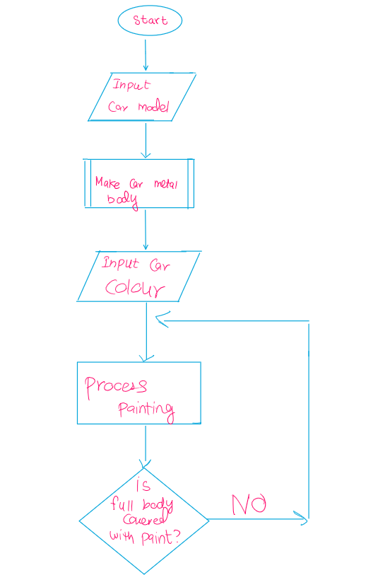

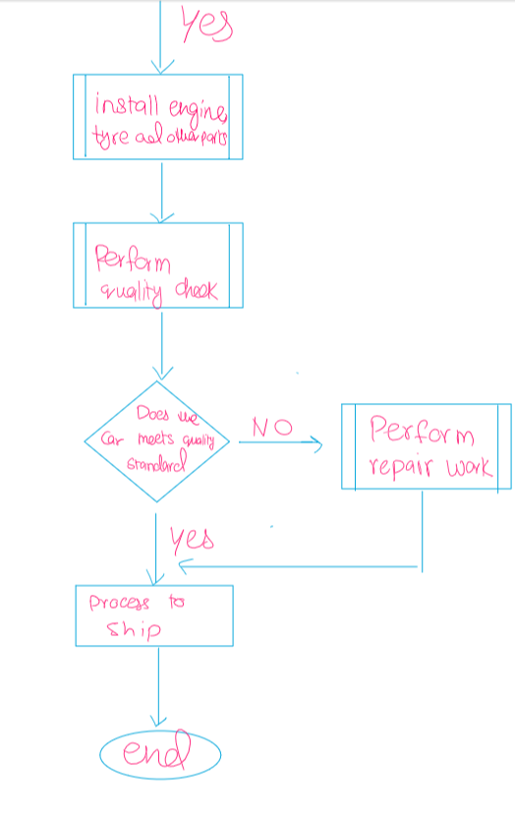

**7. Implement an algorithm for making a simple calculator with all the operators (+,-,*,/,%)**

1. Take input from user for 2 numbers
2. Ask user for operator to perform on numbers
3. Use case statement to calculate result by applying operator
4. Output result

9. Why we use .gitignore?

The .gitignore file extention is used in Git to specify which files and directories should be ignored by github

10. Difference between Algorithm and Pseudocode

Algorithm provides step by step solution how a problem will be solved whereas pseudo code is a programming code written in English language without following the syntax of any programming language